Gmail Link is present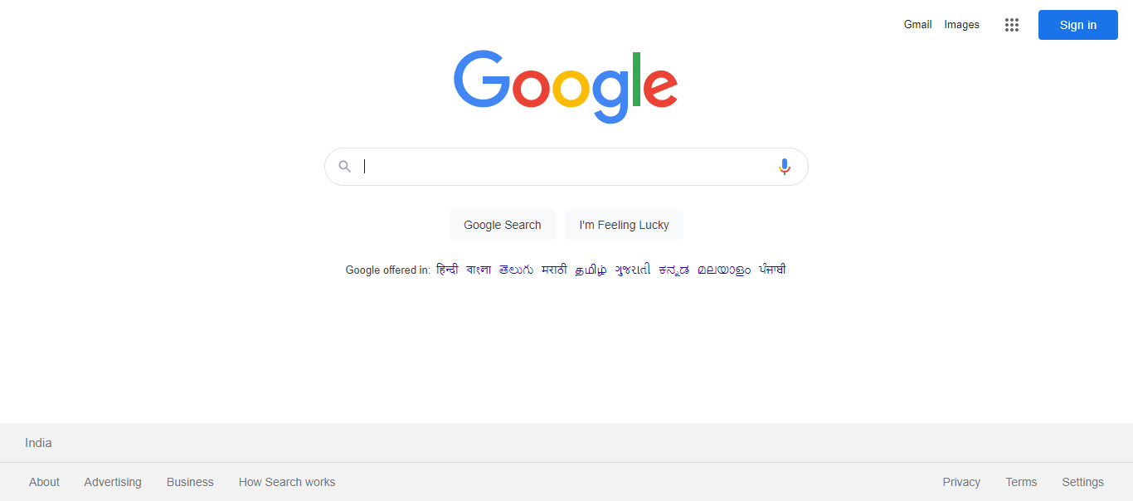Images Link is presentHamburger Menu is present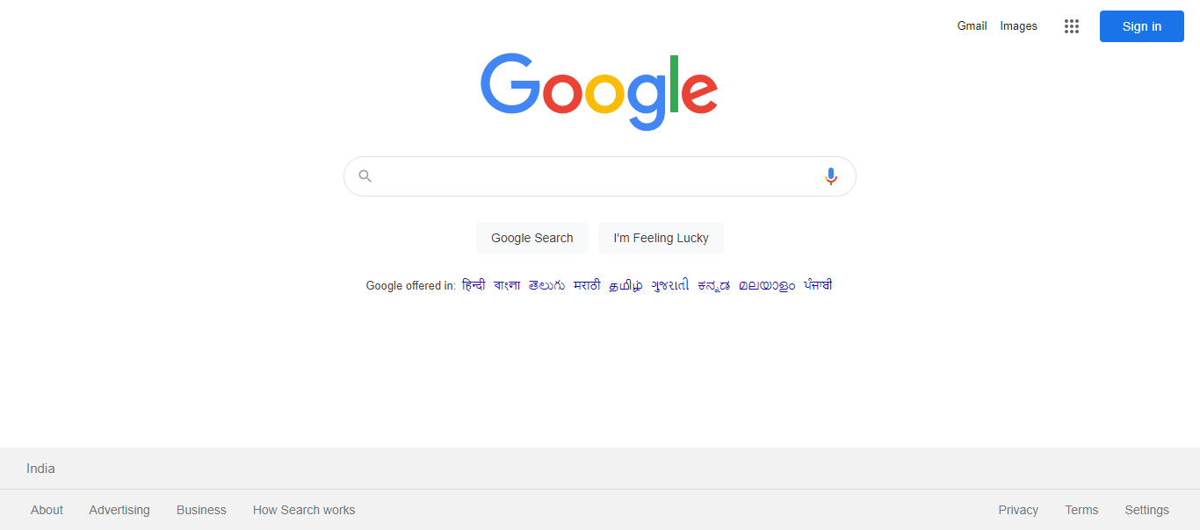SignIn Button is presentGoogle logo is presentInput Search textbox is presentGoogle Search button is presentI'm feeling lucky button is presentGoogle Offered In text is presentIndia text is presentAbout link is presentAdvertising link is presentBusiness link is presentHow Search Works link is presentPrivacy link is presentTerms link is presentSettings link is presentSearch results are displayed